HOCKEY
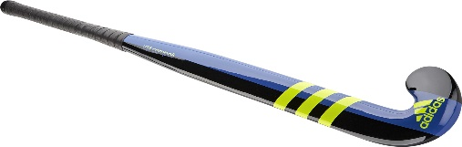
Equipment:
This Photo by Unknown Author is licensed under CC BY
1 Hockey stick
1 ball
5 cones
AIM: Improve dribbling on the straight

Equipment:
This Photo by Unknown Author is licensed under CC BY
1 hockey stick
1 ball
5 cones (placed in a circle roughly 7m diameter)
Aim: Improve dribbling at speed to points on the clock face

Equipment:
This Photo by Unknown Author is licensed under CC BY
1 Hockey stick
1 ball
10 cones to be set up in pairs as gates to travel through
AIM: How do you stop the ball in between the gates?
ALL ACTIVITIES TO BE DESIGNED BY PUPILS AND THEN COMPLETED UNDER TIME RESTRICTIONS SET OUT BY THE TEACHER

NB: Use the FLAT side of the stick, don’t let it hit your feet, Left hand at the top & Right ¾ way down, bend your knees
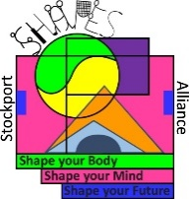

NETBALL
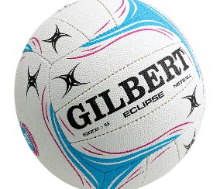
Equipment:
This Photo by Unknown Author is licensed under CC BY-SA-NC
1 netball
Outside wall
AIM: Improve chest passes (DOUBLE FOOTED LANDING, 1 / 2 LANDING)

Equipment:
This Photo by Unknown Author is licensed under CC BY-SA-NC
1 netball
Chalk
Outside Wall
AIM: Improve accuracy using a variety of throws

Equipment:
5 Cones set up in a fan
This Photo by Unknown Author is licensed under CC BY-SA-NC
*
. . . .
Aim: To improve sprinting out to receive a ball (imaginary)

ALL ACTIVITIES TO BE DESIGNED BY PUPILS AND THEN COMPLETED UNDER TIME RESTRICTIONS SET OUT BY THE TEACHER
NB: Remember DO not RUN with the ball

FOOTBALL

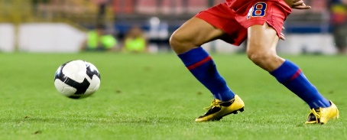
Equipment:
This Photo by Unknown Author is licensed under CC BY
1 football
Outside wall
Aim: 2 touch control – come up with 3 points of how to control and send the ball (think how your kicking foot should be when you strike the ball, what is your body doing, how do you receive the ball off the rebound)

Equipment:
1 football
5 cones
Aim: to dribble the ball with control (set the cones in a straight line & then try in a zigzag line)

Equipment:
1 football
5 Cones set up in a fan
*
. . . .
Aim: To dribble then control the ball at the cone
ALL ACTIVITIES TO BE DESIGNED BY PUPILS AND THEN COMPLETED UNDER TIME RESTRICTIONS SET OUT BY THE TEACHER

Score Sheet
Activity | 1st attempt | 2nd attempt | 3rd attempt
Hockey
Dribbling on the straight
Hockey
Clock face

Hockey
Gates

Netball
Chest passes against the wall
Netball
Accuracy

Netball
Sprinting

Football
Send and stop

Football
Dribbling

Football
Fan control

