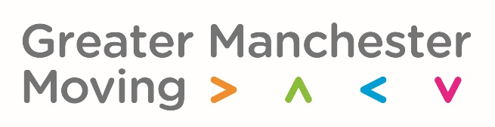
GM Moving Creative and media buying brief
Issued January 2022
GreaterSport is a high performing charity passionate about changing lives through physical activity and sport. Following our historic devolution agreement with the Government, we’re to deliver the greatest and fastest improvement to the health, wealth and wellbeing of the 2.8 million people who live in Greater Manchester (GM).
The GM Moving In Action plan (here) is a key part of realising our vision. This sets out our ambitious aim to support active lives for all.
Inspiring people to move more has never been more important - the increasing scientific evidence is that being physically active reduces chronic disease and illness and as the region recovers from Covid-19 there is an expectation that our physical activity campaigns will play a significant part in inspiring behaviour change that leads to better health outcomes for residents . Our charity status and the importance of our simple but important message mean that we are determined that our continued investment into these campaigns must be well evidenced and well spent.
Since 2019 we have been delivering public facing marketing communication campaigns to inspire residents to move more and make small changes that can lead to big health and wellbeing gains.
You can find out more about our campaigns below:
That Counts! and here
Keep Moving
The GM Way
As we continue to inspire people to move, our marketing plans for 2022 look a little different and we are now seeking an agency/ies to support us in developing our future public facing communications.
We envisage that our marketing plan for 2022 will see us re-run some of our existing creative assets – particularly our Keep Moving assets that were launched in September 2021. We are also keen to create new content aimed at motivating: South Asian residents, residents of African heritage and older adults (50 plus) at increased risk of trips and falls.
It is important to understand that this brief sits within a wider campaign delivery strategy and that other audience cohorts will be targeted with moving messages through alternative, but complementary marketing campaigns.
Further information about the marketing campaigns:
- We are Undefeatable the campaign that inspires people living with long term health conditions to move more by focusing on positive stories of what is possible.
- This Girl Can the campaign to encourage females to be active.
- Couch to Fitness a specific strand of the campaign creative that’s aimed at Black women
- That Counts! the GM campaign targeting inactive cohorts in the general population but specifically those in lower segments (potentially workless adults).

Keep Moving
Keep Moving is starting to move our communications beyond awareness and GM Moving are looking for
into motivation. The campaign seeks to encourage action, and inspire adoption of ongoing movement.

People often feel as though they don’t have the time to fit in exercise, so by creating a concept around reminding people to get active in the moment of targeting, we’re making the most of trying to encourage action straightaway. For example, within advert breaks when people are in between programmes, encouraging 5 minutes of activity such as star jumps, arm curls or walking on the spot. By creating a concept of small digestible chunks of exercise, we’re trying to educate people to fit in activity in their everyday lives and to do the movement at the point of seeing the campaign message.

Our continuing objectives
• To build on the learnings and awareness from previous campaigns of That Counts! and the first phase of Keep Moving.
• Create a relatable, action-based creative campaign that is developed through insight and tested with target audiences
• To inspire people into taking short bursts of movement in order to encourage further and more regular movement
• Targeting the most inactive audiences, the campaign needs to reach people through targeted and considered media channels, utilising the modest budget in the most cost-effective way.

Examples of the OOH posters for Keep Moving are provided in the annex to confirm existing campaign look and feel.
The requirements
To plan, create and deliver a continuation of our Keep Moving creative campaign that is able to be meet our objectives to inspire inactive residents to move more everyday and to lead a more physically active life.
The campaign needs to be flexible enough to appeal to the general GM inactive population but also to have specific strands that target South Asian audiences, African heritage audiences and older adults most at risk of trips and falls with clear messaging about the activities that most reduce those risks.
Reaching South Asian audiences
Delivering campaign messages to South Asian cohorts is new to our public facing communications and we are looking for an agency that can demonstrate knowledge of this audience in terms of effective media placement, channels to engage the audience and routes in to develop co-create the creative assets with members of the South Asian communities found across GM.
We have previously struggled to represent Asian (and people of African heritage) people in our campaign work – whilst they were not previously specific audience cohorts, we recognise for example that our existing campaign assets (imagery) are not as representative as we would strive for going forwards. It’s important to us that the successful agency can tangibly offer real expertise in helping us to become more representative and deliver meaningful, appropriate and relevant ‘move more’ messages that engage this audience group.
What’s needed?
- Creative campaign – plan and develop the new Keep Moving creative campaign
- Media buy – support targeted media buy to reach inactive GM populations and specific audience groups and in specific geographic (borough) locations.

Agency experience and strengths
The agency must be a have relevant creative development experience (similar behaviour change campaign work examples) as well as specialist media-buying experience with specific and detailed knowledge of the Greater Manchester media landscape. By Greater Manchester, we include all 10 local boroughs and the local media opportunities that exist within those boroughs - these might include free media channels at a hyper local level and we are keen to exploit all opportunities to extend the campaign messaging, not just traditional paid for routes.
Our budgets are small but we believe with the right media buying agency partner we can maximise every pound through careful negotiation and that clever media buying.
The agency should also demonstrate knowledge of reaching and working with South Asian audiences.

Budget
The envelope of available budget is £72,000 inclusive of VAT. This budget needs to include creative assets development and media buy.

Tender requirements from responding agencies
Responding agencies are expected to provide the information as indicated in the table beneath, which also provides the weighting/scoring criteria.

Requirement | Weighting
- Team  Outline who will be part of the team detailing agency/agencies and relevant experience and credentials for this brief | 10%
- Experience  Provide evidence of delivering GM wide media campaigns that are demonstrably effective at reaching the target audiences and delivering audience reach and/or engagement. Preferably examples will include:  - Behaviour change/social movement campaigns  - Reaching whole population and/or specific cohorts  - Inclusive campaigns that target low socioeconomic and inactive groups  - Campaigns that have reached miniority audiences  - Examples of campaigns that have in whole or in part been co-created with the communities they are targeted at (ie through co-creation workshops or other methods)  - Demonstrate hyper local (at borough level) media knowledge and experience  - Demonstrate how added value has been achieved (ie through negotiations with media owners to secure additional sites/spots etc) | 50%
- Indicative creative options and media buying options for Keep Moving  Broad recommendations for the campaign creative and media buy.  At this stage we aren’t seeking finished creative work but we are keen to see strategic thinking and creative direction (possibly a range of tissue creative ideas). The creative must sit witin the look and feel of the existing campaign and creative examples of the OOH posters are provide in the annex. | 40%
Total | 100%

Annex: Keep Moving look and feel – OOH posters

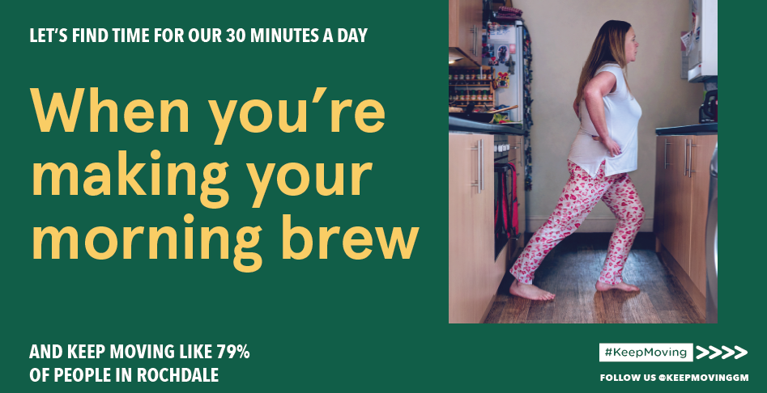

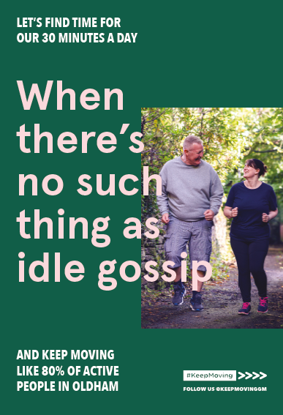

Timings
Activity | Timeline
Brief issued | Week commencing 10th January 2022
Closing date for submissions | Friday 21st January 2022
Agencies shortlisted | Week commencing 24th January 2022
Shortlisted agencies invited to present their response (virtual meeting) | Date to be confirmed after shortlisting
Agency appointment | Expected form mid February

Contact
For further details or information or any questions please contact: Helen-Louise Smith
helen-louise@gmmoving.co.uk

Tenders to be submitted by 16:30 on 21st January 2022 to helen-louise@gmmoving.co.uk

