Child Protection Incident Report Form (CPIRF)

To be completed by a member of Greater Manchester Moving staff or voluntary worker wishing to report concerns / allegations / disclosures regarding abuse.

Your first name: |  | Your surname:
Your position: |  | Your contact no.:
Child’s first name: |  | Child’s surname:
Child’s DOB: |  | Child’s Age:
Child’s address: |  | Guardian/Parent’s address:
 |  | (if different)
Child’s sex: | M [ ] F [ ] | Home Tel. No:
Disability (if relevant):
Time and date of incident / disclosure:
Nature of incident / disclosure:
Are you reporting your own concerns [ ] or those of someone else [ ] ? (please tick)
If someone else’s please state their position:
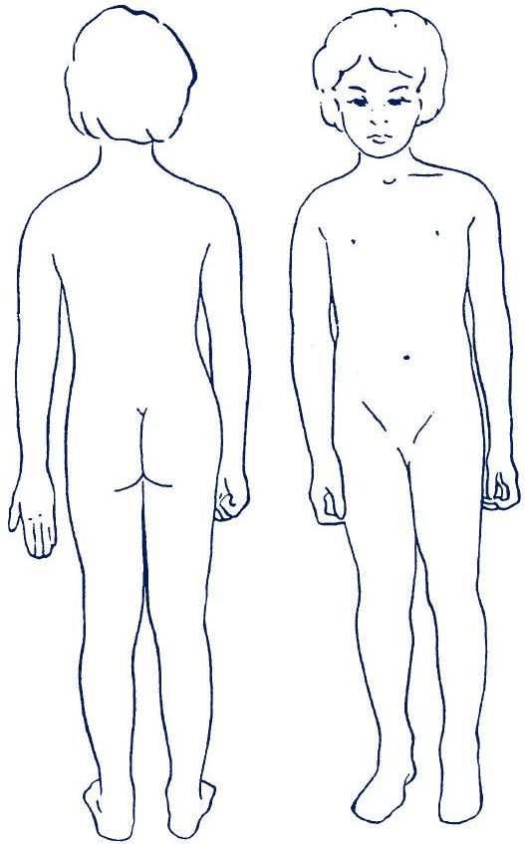Report the facts as you observe them
(including visible injuries / behaviours):
Report the account of the person making the allegation / disclosure (using their words where possible) making clear distinctions between fact and opinion / hearsay:

Summarise the child’s account of the incident(s) if available
Detail any witnesses to the incidents with names and contact details:
Detail any actions taken, including anyone else who has been consulted, with names, contact details and advice received etc:
Have the child’s parents been contacted: YES [ ] NO [ ] (please tick)
If YES, what has been said?
Use this space to record any other facts / circumstances which you think may be relevant:

Once completed, the original of this form should be lodged with the Greater Manchester Moving Lead Officer / Chief Executive as appropriate within 24 hours. Remember to maintain confidentiality on a ‘need to know’ basis – only share information if doing so will protect the child.

